**Document Type: QA Test Result**

Report Name: 9C_A_01 Item wise daily Sell

Tester Name: Md. Amin Khan

Test Date: 18-11-2023

1. Data mismatch in DB with PDF

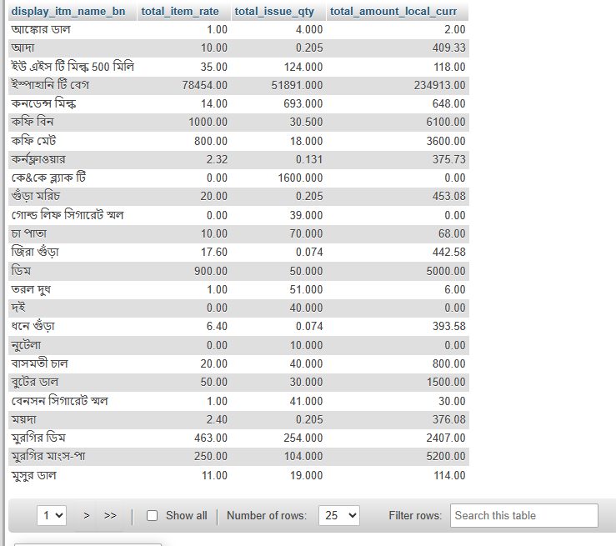

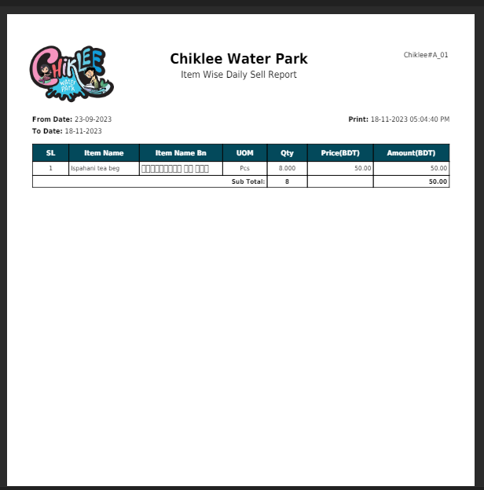

1. Item Name BN is not showing
2. Amount is showing wrong.